ASSIGNMENT 3

NAME: Shaik Khushnuda

EMAIL ID: [208x1a0590@khitguntur.ac.in](mailto:208x1a0590@khitguntur.ac.in)

Phone: 8977334292

Roll number: 208x1a0590

College: kalam haranadhareddy institute of technology, chowdavaram, Guntur.

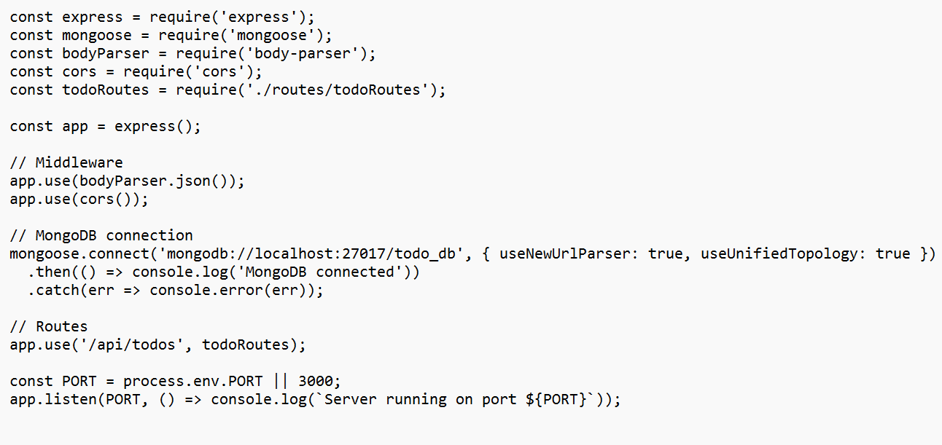**Create a RESTful API using express.js and create a database and index in MongoDB**

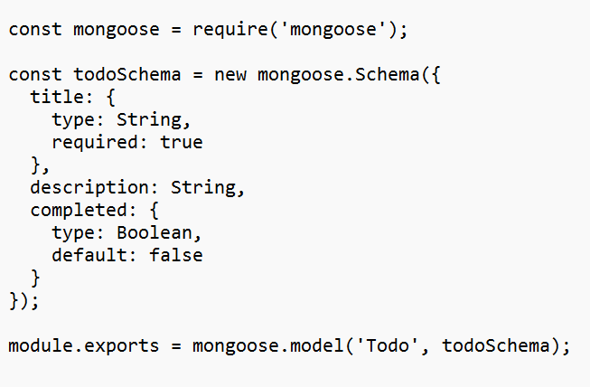

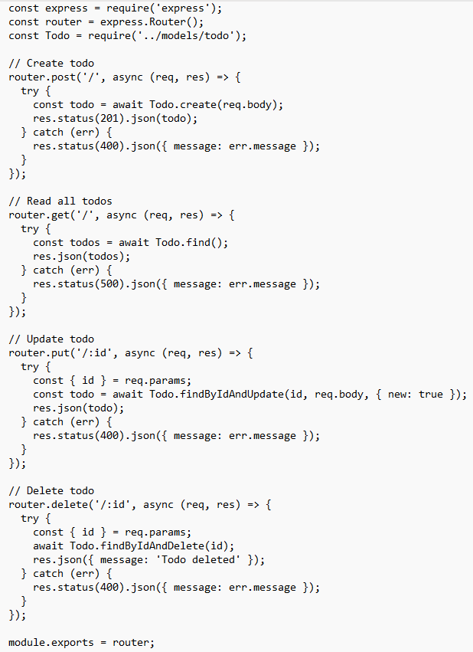

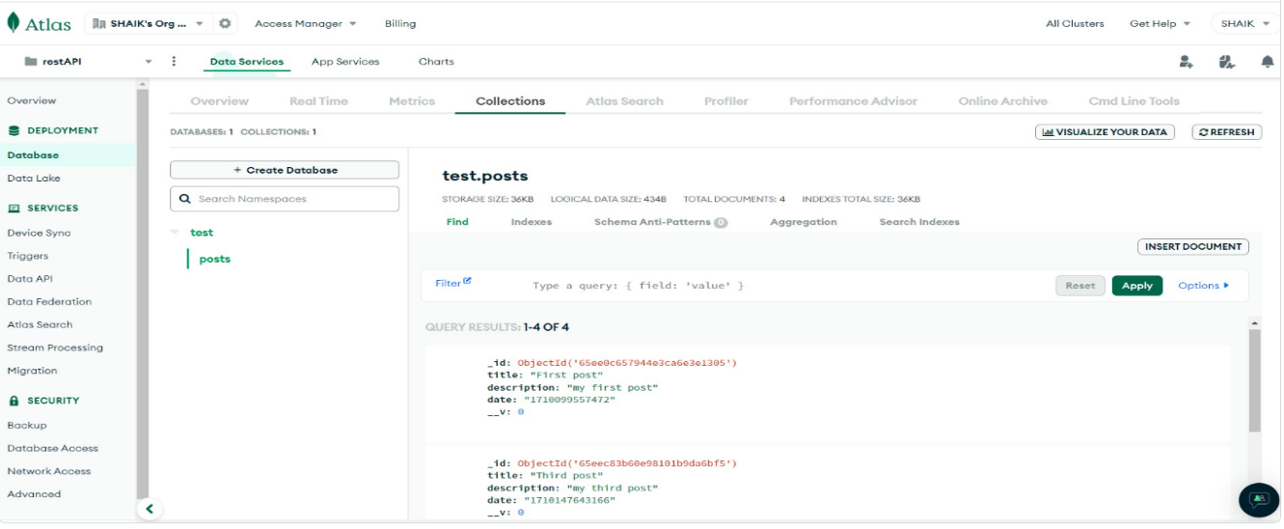OUTPUT: